05-08 Forester HVAC color change installation

- Carefully remove the HVAC control module from your dash and remove it from the radio surround trim piece.

- Rotate all three knobs all the way to the left on both yours and the one you receive.

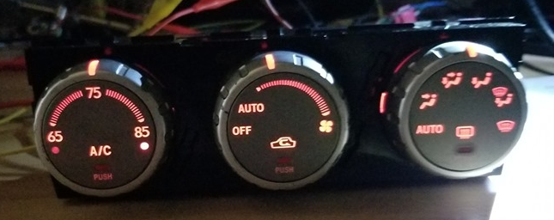

- Place both HVAC controllers knob side down on a soft cloth. Remove the 6 silver screws from the back of both.

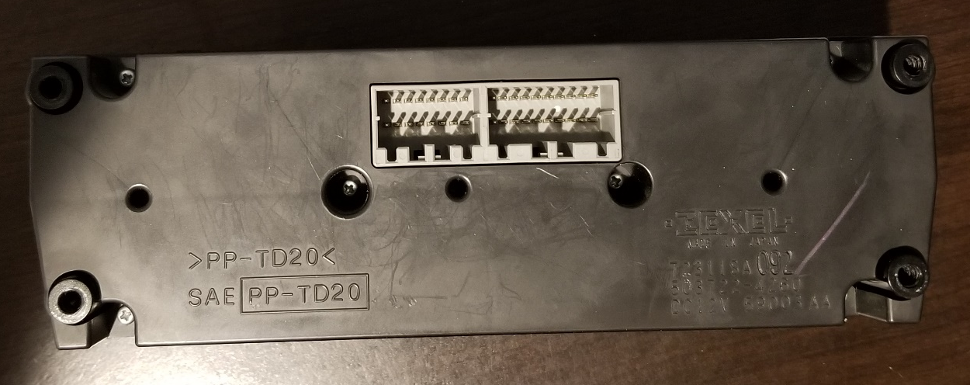

- Remove the backs from both HVAC controllers. It will just lift off after all the screws are removed.

- Swap the two circuit boards. Make sure the 3 small knobs from the front cover of the HVAC controller are a lined with the 3 holes in the circuit board.

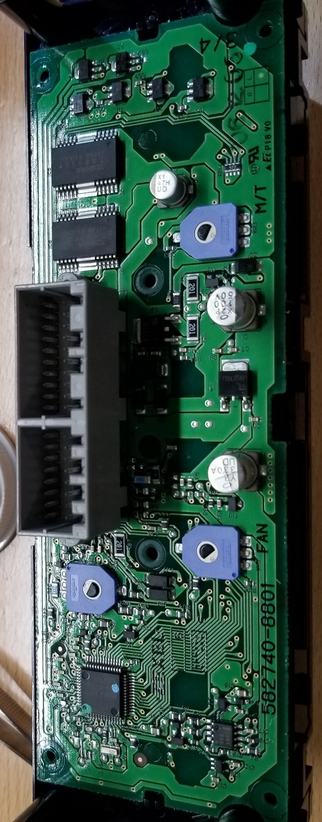

- Reinstall the back covers on the HVAC controllers and secure the 6 screws (don’t over tighten them). Make sure you do not mix the two covers, as they may be different.

- Remount your original HVAC controller into the radio surround and reinstall.

- Test out your HVAC, check that all 3 knobs turn all the way and all functions work.

